**Setup Docker**

* sudo apt update
* sudo apt install apt-transport-https ca-certificates curl software-properties-common
* sudo apt install docker.io
* docker - - version

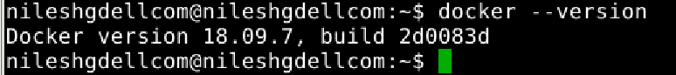

**Setup GitHub Repo**

* Create a repo in Github.
* Git clone <https://github.com/nile1/Devops-Certification.git>
* 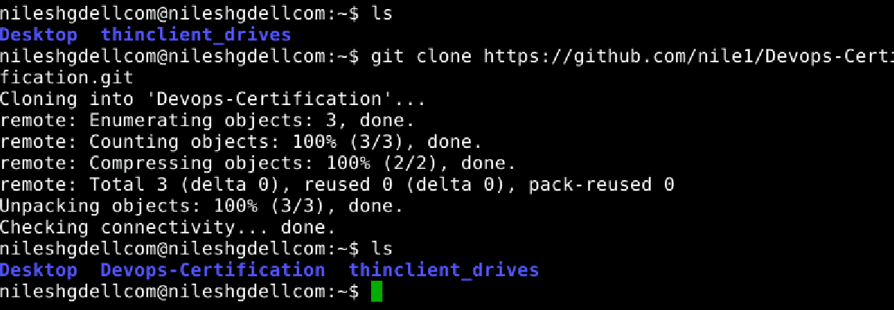
* Add your project V1 to it.
* Git add -A
* Git commit -m ‘Version 1’
* Git push
* 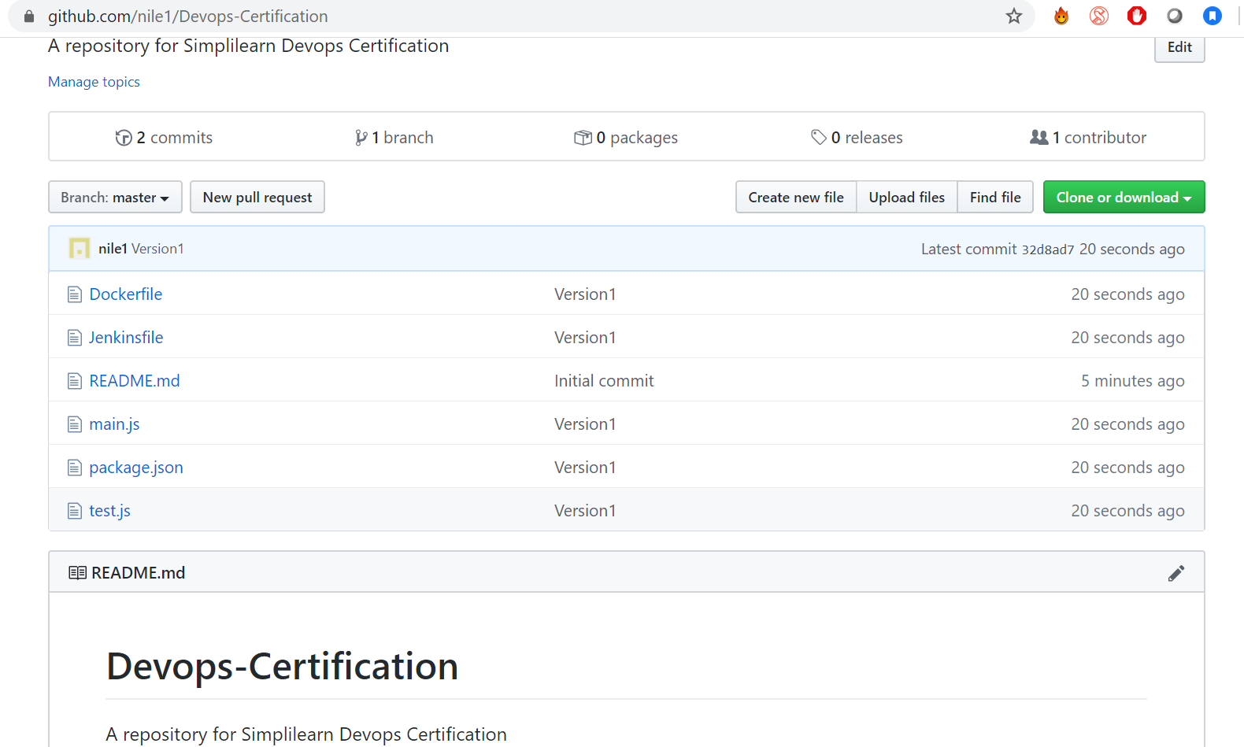

**Create Dockerfile**

* FROM ubuntu
* RUN mkdir -p /home/node/app/node_modules && chown -R root:root /home/node/app
* WORKDIR /home/node/app
* COPY package*.json ./
* USER root
* RUN apt-get update
* RUN apt-get -y install curl gnupg
* RUN curl -sL https://deb.nodesource.com/setup_13.x | bash -
* RUN apt-get -y install nodejs
* RUN npm install
* RUN node -v
* LABEL maintainer "Nilesh.g@dell.com"
* HEALTHCHECK --interval=5s \
* --timeout=5s \
* CMD curl -f http://127.0.0.1:8000 || exit 1
* COPY --chown=root:root . .
* EXPOSE 8000
* CMD [ "node", "main.js" ]

**Create a new Docker Container and test it**

* Docker build . -t devops/container
* docker run -it -p8000:8000 devops/container
* 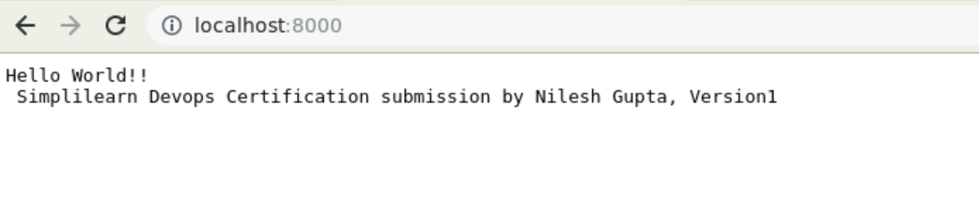

**Install Jenkins and start Jenkins server**

* sudo apt install Jenkins
* sudo systemctl start Jenkins
* sudo systemctl status Jenkins
* 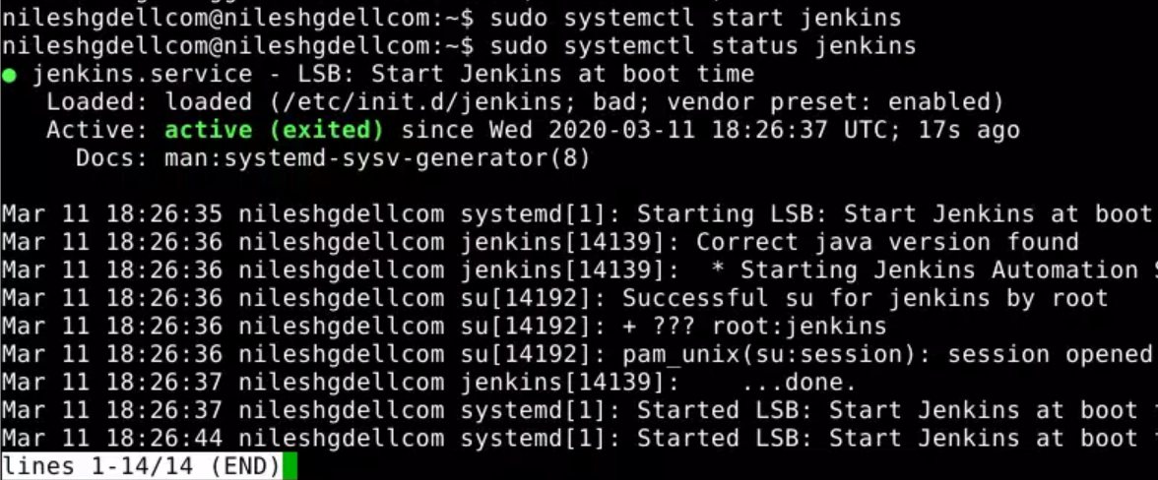
* sudo gedit /var/lib/jenkins/secrets/initialAdminPassword
* 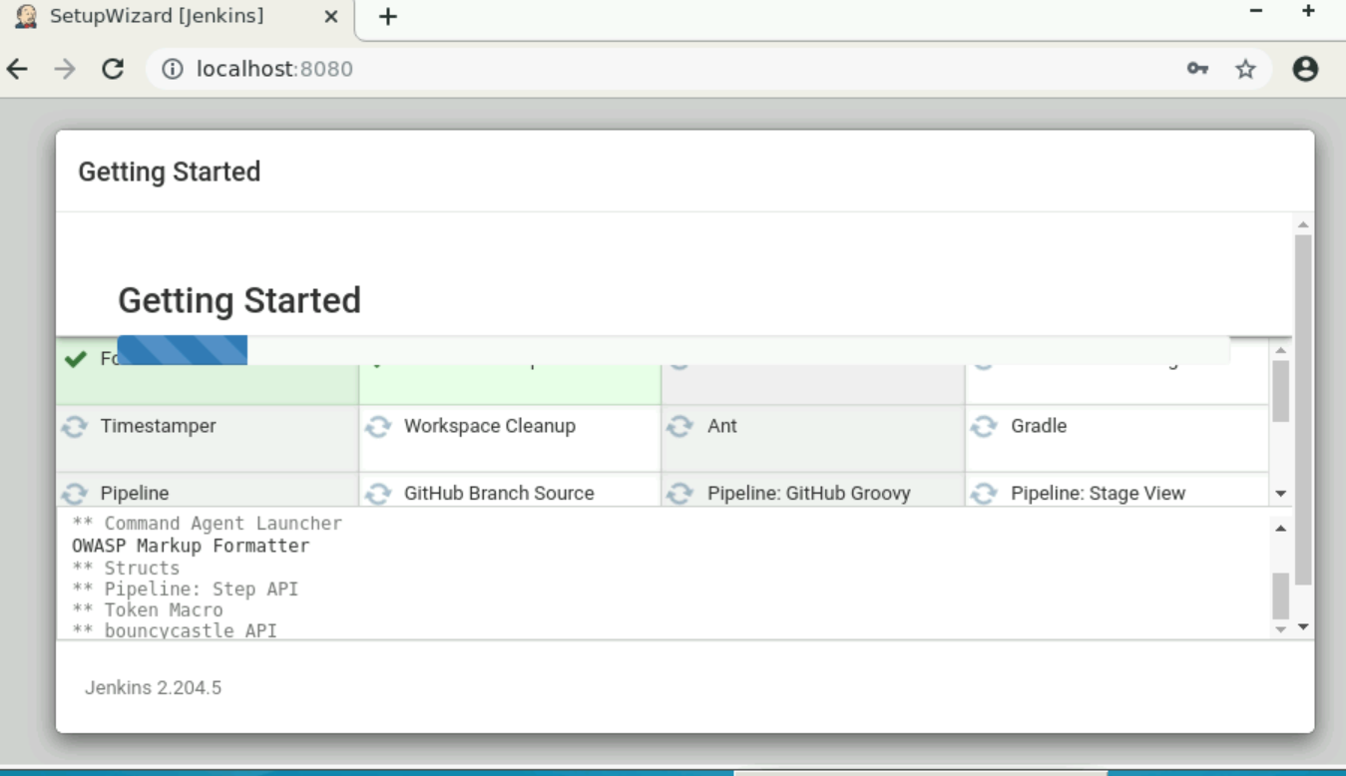
* Install CloudBees Docker Build and Publish, plugin for Jenkins

**Create a CI/CD Pipeline in Jenkin**

* 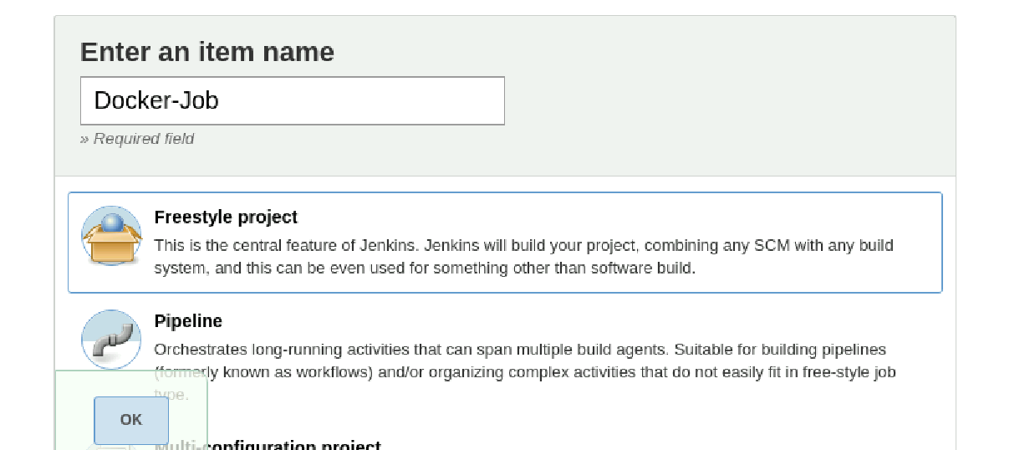
* 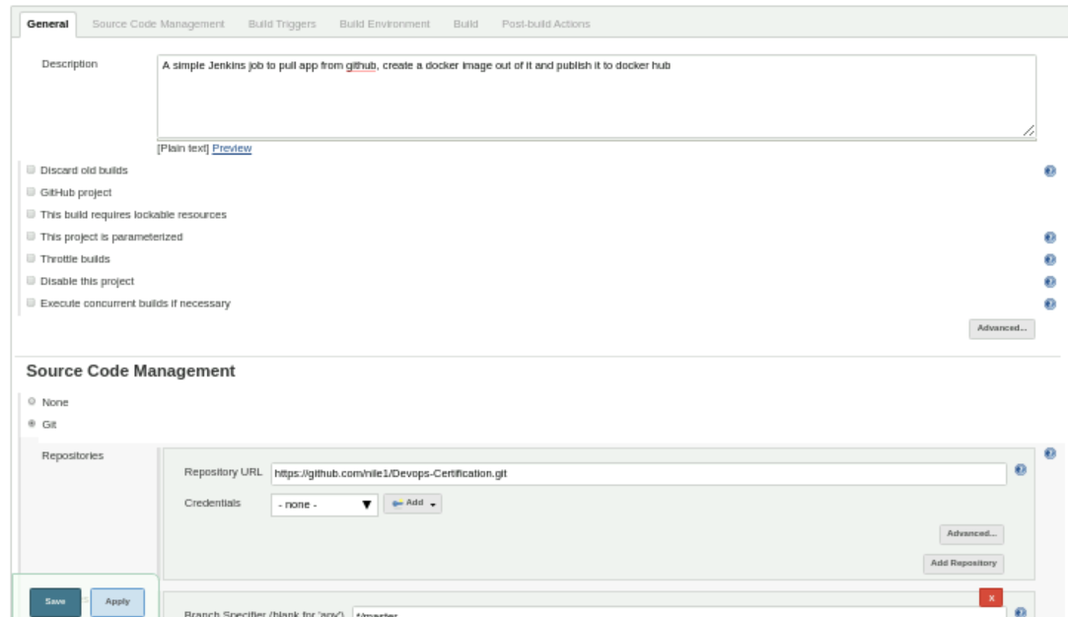
* 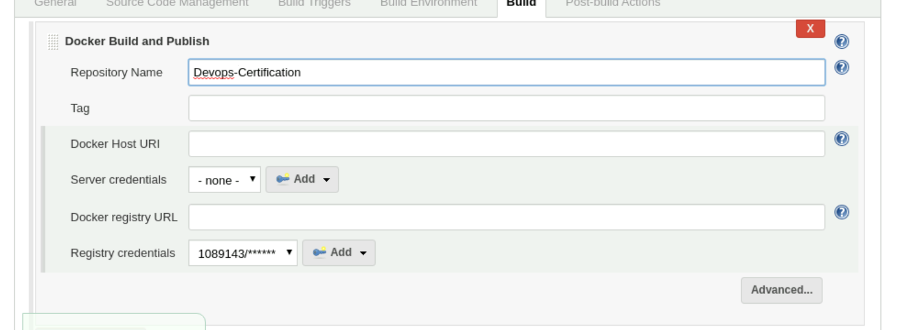
* Run the Job. 
* 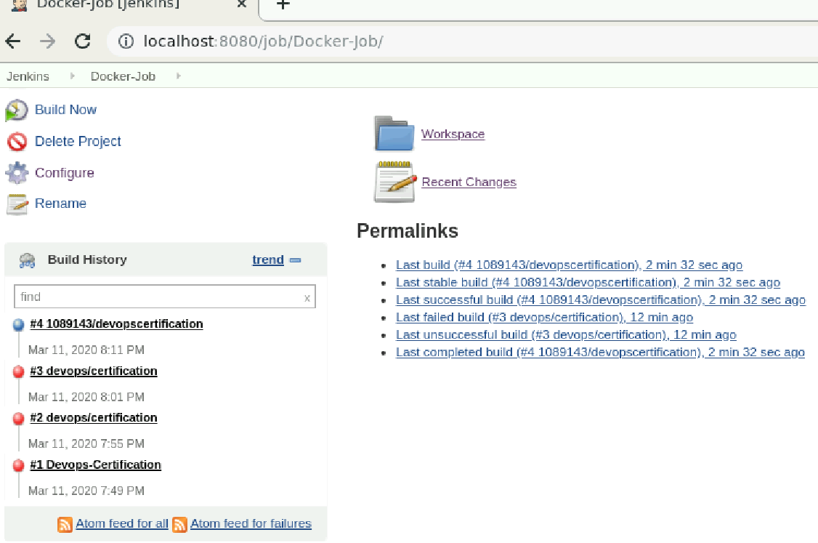
* Forth Build is successful.
* Image automatically uploaded to Docker Hub
* 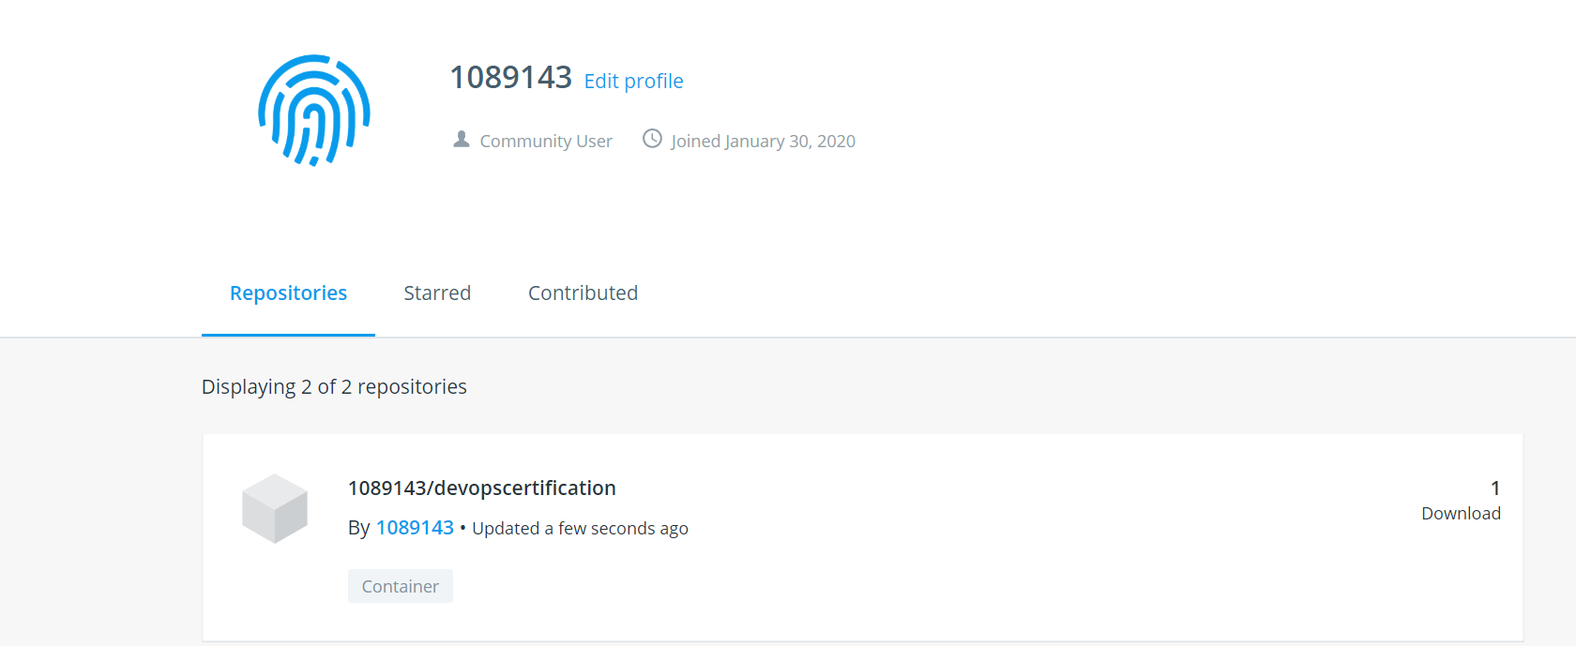

**Changing Git Version.**

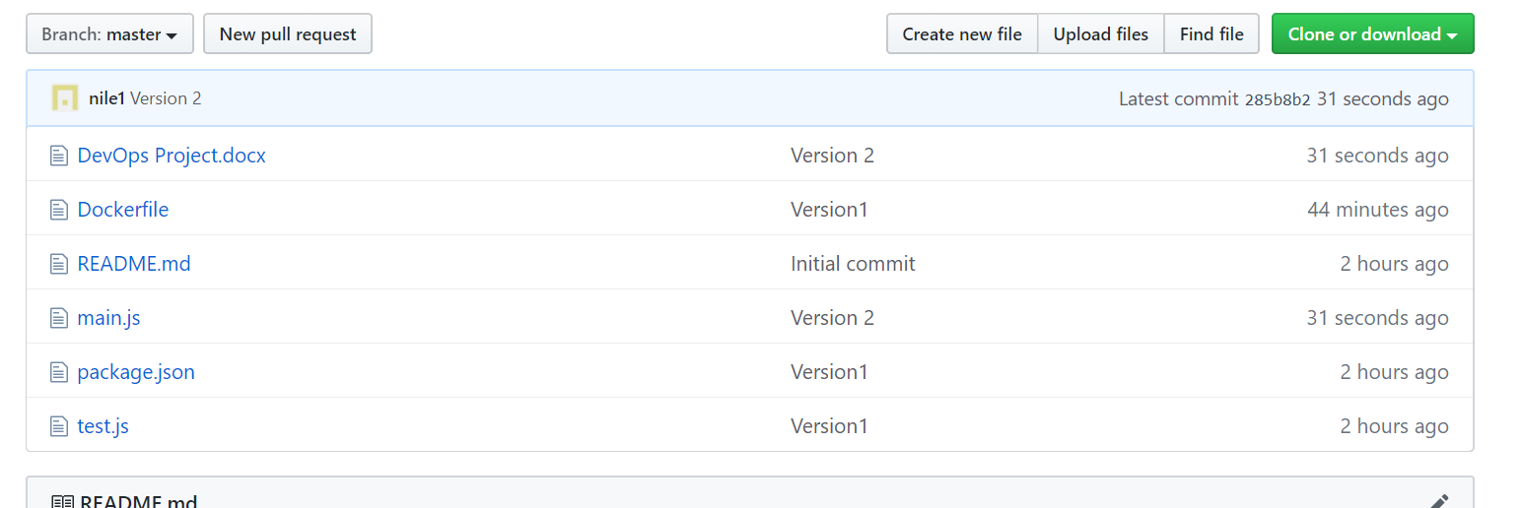

Version 2

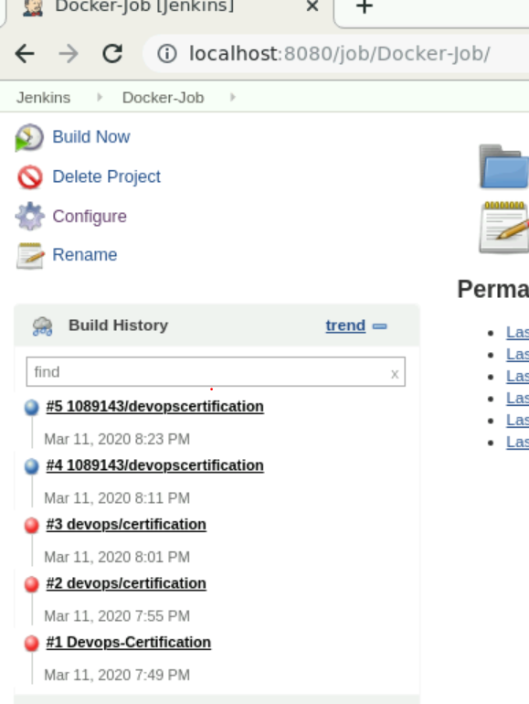 Jenkins Build History

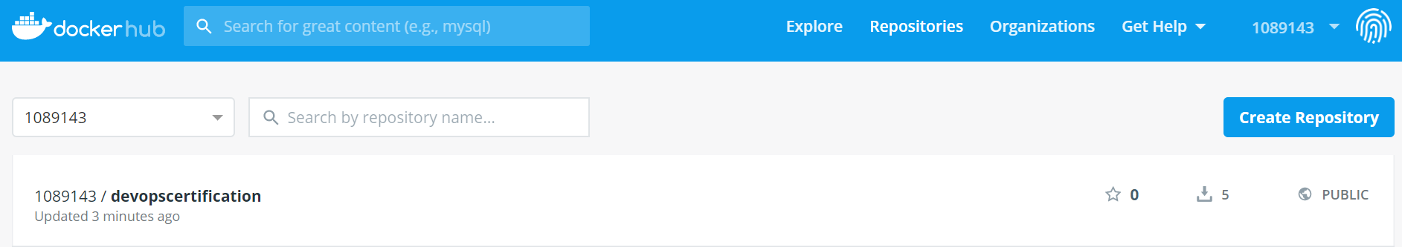

Docker-Hub Updation.

**Pulling image from dockerhub and running**

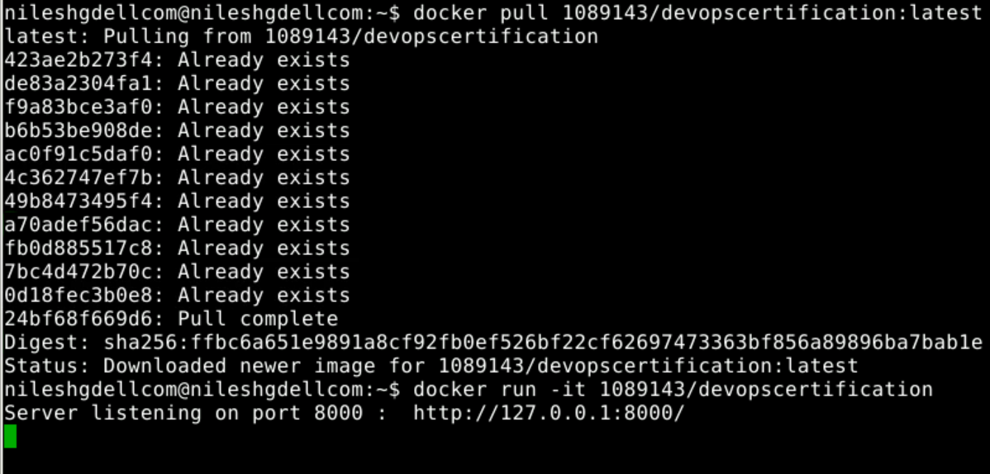

Docker pull and run

